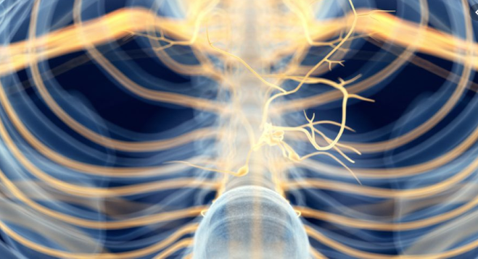

**Gut Health & The Vagus Nerve**

Victor Briere is an Ayurvedic Doctor and co-founder of Pacific Coast Ayurveda. He will be presenting the connection between the vagus nerve and gut health. The Ayurvedic approach often includes diet and lifestyle changes, medicinal herbs, yoga-therapy, other mind-body therapies.

**Wednesday, Sept 11**

**5:30 – 6:30p.m.**

**Bill Platt Training Center**

**38901 Ocean Dr., Gualala**

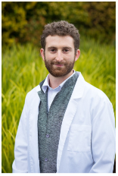

**Victor Briere, A.D.**

A Free Workshop Hosted by MHA

*Working together, building a healthier community.*



For more information contact MHA at (707) 412-3176 X 101 or email info@mendonomahealth.org